**Cougar Online Webstore:**



<https://az-tucson.intouchreceipting.com/>    OR

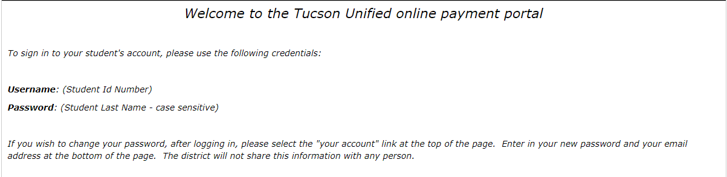



After signing in follow prompts to Items at Student’s School:



Next Choose the Category for the Item you would like to purchase or contribute to:



Once items have been selected proceed to Checkout to enter financial information.