MLA Style - 8th Edition
In the 8th Edition of MLA, you include the “core elements” of the sources. Core elements are those basic pieces of information that should be common to all sources, from books to articles, from lectures to tweets. The MLA core elements for ALL resource types, along with the punctuation that should follow each element, are written in order as follows. (Unavailable elements are simply omitted.)
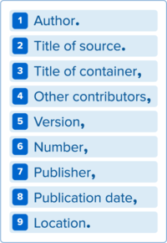
*Containers
The concept of containers is crucial to MLA style. When the source being documented forms part of a larger whole, the larger whole can be thought of as a container that holds the source. For example, a short story may be contained in an anthology. The short story is the source, and the anthology is the container. A source can have two containers. For example, an article could be contained in a magazine which could be contained in a database.
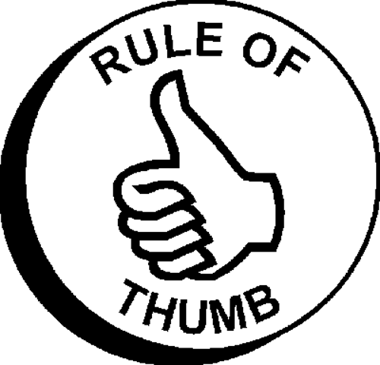
√ Omit http:// when citing URLs.
√ Although not required, MLA encourages the use of an access date when no copyright date is given.
√ Book & website titles should be in italics.
√ Article names (part of a larger work) periodicals, television episodes, and songs should be in quotation marks.
√ When an organization is both author and publisher of a work, the organization’s name is given only once, usually as publisher. No author is given.
√ When a source has 3 or more authors, only the first one is used, followed by “, et al.”
√ “pp.” is used for page range; “p.” is used for a single page.
√ Common terms (editor, translator, etc.) are no longer abbreviated. Volume (vol.) and number (no.) are.
RULES OF THUMB:
MLA Template
1 AUTHOR.
2 TITLE OF SOURCE.
Container 1
3 TITLE OF CONTAINER, *Is source found within larger work?
4 OTHER CONTRIBUTORS, *Edited by? Translated by? Etc.
5 VERSION, *Edition?
6 NUMBER, *Volume, number, season, episode?
7 PUBLISHER, *Organization that produced source?
8 PUBLICATION DATE,
9 LOCATION. *Book/pages? *Web/URL? DOI?
Container 2 (example: magazine article from a database)
3 TITLE OF CONTAINER,
4 OTHER CONTRIBUTORS,
5 VERSION,
6 NUMBER,
7 PUBLISHER,
8 PUBLICATION DATE,
9 LOCATION.
A basic citation format should have the elements listed in the following example, as available, with the punctuation shown. You would omit elements that don’t exist or are unnecessary.
Author. Title. Title of Container. Other contributors, Version,
Number, Publisher’s name, Date of Publication, Location.
Book with one author
Jacobs, Alan. The Pleasures of Reading. Oxford UP, 2011.
Website
“Woman Saves Swimmer.” CNN.com, 15 Oct. 2006,
www.cnn.com/2006/WORLD/asiapcf/10/15.
Anthology
Rose, Shirley K., and Irwin Weiser, editors. The Writing
Program Administrator as Researcher. Dover, 1999.
Multiple essays from an anthology
Peeples, Tim. “Finding Ourselves in the Past.” Rose and
Weiser, pp. 153-67.
General Encyclopedia
“Ideology.” World Book Encyclopedia. 2014.
* For more examples go to: http://library.uco.edu/instruction/handouts/MLAStyle8th.pdf

